Paper Title (16 Bold)

Author (14)
^{1,2}Student, Kakatiya University of Engineering and Technology, Warangal, Telangana
³Student,Anurag Group of Institutions,Hyderabad, Telangana.
Corresponding Author: xxxx (10)

--------------------------------------------------------------------------------------------------------------------------------------
Date of Submission: 07-06-2020 Date of Acceptance: 23-06-2020
---------------------------------------------------------------------------------------------------------------------------------------

ABSTRACT: (11 Bold) This research paper is about to control the engine valves of an one cylinder 4-stroke engine with a computer controlled electromagnetic actuator. There are many possibilities in electromagnetic devices. We chose a push solenoid to actuate the engine valve. For controlling the solenoid, we chose a user interface with control options. The user interface communicates serially with a microprocessor. The microprocessor monitors and reports the engine’s performance and control the opening/closing of the engine valves. The ultimate goal is improved efficiency, decrease pollutants, and produce maximum power throughout the RPM range with a camless engine.
KEYWORDS: (11 Bold) Actuator, Microprocessor, Enginehead, L293D Current Amplifier, IRF 3205 MOSFET.

- INTRODUCTION(11 Bold)
In this paper i.ecamless engine, the valve motion is controlled directly by a electromagnetic actuator there’s no camshaft or connecting mechanisms .Precise electromagnetic actuator or solenoid controls the valve operations, opening, closing etc. The project looks at the working of the electromagnetic actuator camless engine, its general features and benefits over conventional engines Since the invention of engine and till now four stroke IC engines are working on camshaft Mechanism. Although the conventional system has proven to be convenient and safe. Its fixed valve timing is necessarily a compromise of combustion stability, fuel economy and maximum torque objectives. Cam is an integral part of an engine as it controls valve actuation which in turn is responsible for supply of air-fuel mixture into the combustion chamber and for the removal of exhaust gases from the combustion chambers.
Although a significant numbers of engine valve-actuation systems including cam-based and cam less mechanisms have been already introduced by several researches and companies, only few types of these systems (mainly cam-based) have been employed on commercial vehicles due to the liability, durability and cost issues. Cam-based valve systems offer reliable and durable functionality, the cam less valve trains can vary valve lift and more timings to a greater extent comparing to the cam-based types. Among various categories of cam less mechanisms, the electromagnetic actuator system is the most desired one.
[1].Camless actuation offers programmable flexibility in controlling engine valve events. However, a full range of engine benefits will only be available, if the actuation system can control lift profile characteristics within a particular lift event. Control of the peak value of valve lift is a first step in controlling the profile. The paper presents an adaptive feedback control of valve lift for a springless electrohydraulic valvetrain. The adaptive control maintains peak value of lift in presence of variations in engine speed, hydraulic fluid temperature and manufacturing variability of valve assemblies. The control design includes a reduced-order model of the system dynamics. Experimental results show dynamic behavior under various operating and environmental conditions and demonstrate advantages of adaptive control over the non-adaptive type.
[2].The internal combustion engine is a device which basically converts the heat energy into mechanical energy. The cam has been an integral part of the IC engine from its invention. As with the demands for better fuel economy, more power, and less pollution, motor engineers around the world are pursuing a radical “camless” design that promises to deliver the internal combustion engine’s biggest efficiency improvement in years. The article looks at the working of the electrohydraulic camless engine, its general features and benefits over conventional engines. In this article we focused on a basic overview of camless engine along with its design principle, components and its merits over other conventional engines.
[3].A camless engine proof-of-concept prototype was completed on the basis of the use of piezoelectric control of a hydraulic actuator. This novel approach was taken in an attempt to enhance earlier solenoid-based camless engine prototypes, several of which are reviewed as an introduction to camless engine technology. Following a historical review, an overview of the piezoelectrically- controlled camless engine actuator is discussed. The prototype system is capable of displacing an engine valve up to 12.4 mm, and valve actuation frequencies of up to 500 Hz have been obtained. The proof of concept can be considered successful, as it demonstrates the potential of piezoelectric control of hydraulics for use as an internal combustion engine valve actuator. Furthermore, in conjunction with variable timing, the piezoelectric control based pilot allows for direct regulation of other engine valve parameters including variable lift and seating velocity.
[4].This paper presents the design of Camless Internal Combustion (IC) Engine using the Magnetic platter Disk Sensor instead of conventional mechanism for operating valves. In this work an attempt has been made to integrate the concepts of mechanical and electronics for designing economical, low emission, high performance Camless engine. Objective of this work is to make use of Disk Sensor for developing Camless IC Engine.
[5].The idle speed control problem of a spark-ignited engine equipped with a camlessvalvetrain is considered.
The camlessvalvetrain allows control of the individual intake and exhaust valves of each cylinder and can be used to achieve unthrottled operation, and consequently, optimize the engine performance. We formulate the speed control problem for this engine and show that it exhibits unstable open-loop behaviour with asigni"cant delay in the feedback loop. The instability is intrinsic to the unthrottled operation and speci"c to the camless actuation used to achieve the unthrottled operation. The delay is caused by the discrete combustion process and the sensor/computer/actuator interface. We demonstrate the inherent system limitations associated with the unstable dynamics and the delay and provide insight on the structural (plant) design that can alleviate these limitations. Finally, stabilizing controllers using classical and modern robust design techniques are presented and tested on a nonlinear simulation model. Copyright_2001 John Wiley & Sons, Ltd. (10 Bold)

- SOLENOIDS AS A VALVES IN 2 STROKE ENGINE(11 Bold)
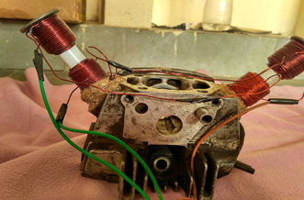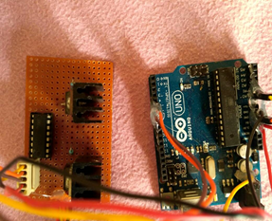

A solenoid is simply a specially designed electromagnet. A solenoid usually consists of a coil and a movable iron core called the armature. Here's how it works. When current flows through a wire, a magnetic field is set up around the wire. If we make a coil of many turns of wire, this magnetic field becomes many times stronger, flowing around the coil and through its center in a doughnut shape. When the coil of the solenoid is energized with current, the core moves to increase the flux linkage by closing the air gap between the cores. The movable core is usually spring-loaded to allow the core to retract when the current is switched off. The force generated is approximately proportional to the square of the current and inversely proportional to the square of the length of the air gap.
When an electrical current is passed through the coils windings, it behaves like an electromagnet and theplunger, which is located inside the coil, is attracted towards the centre of the coil by the magnetic flux setup within the coils body, which in turn compresses a small spring attached to one end of the plunger. The force and speed of the plungers movement is determined by the strength of the magnetic flux generated within the coil.
When the supply current is turned “OFF” (de-energised) the electromagnetic field generated previously by the coil collapses and the energy stored in the compressed spring forces the plunger back out to its original rest position. This back and forth movement of the plunger is known as the solenoids “Stroke”, in other words the maximum distance the plunger can travel in either an “IN” or an “OUT” direction, for example, 0 to 30 mm

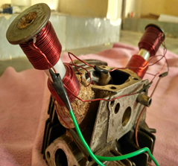
Side View and Front view of Solenoid Operated CamlessEngine

EXPERIMENTATION(11 Bold)
A Regulated 5V DC power supply is feed to Arduino board and IC 7805 Voltage regulator. All microcontrollers operate at low voltages and require a small amount of current to operate while solenoids require higher voltages and current. Hence current cannot be supplied to the solenoid from the microcontroller .This is the primary need for IC L293D.A diode(IN4007) and a voltage regulator (7805) IC are connected in the path ,the diode is used as a one-way check valve. Since these diodes only allow electrical current to flow in one direction.IC 7805 is a 5V Voltage Regulator that restricts the voltage output to 5V and draws 5V regulated power supply. A digital signal generated by Arduino based on the input program is feed to the L293D IC .L293D Is a voltage amplifier that amplifies the 5V into 12V.The L293D IC receives signals from the micro controller and transmits the relative signal to the solenoids .A L293D IC consists of 16 pins in total. 4 ground pins,4-input pins,4-output pins,2 voltage and enable pins. The digital signal output from 7 pin of arduino is feed to 10th pin of L293D(input),output from 7th pin is feed to 14th pin of L293D(output).The 4th,5th and the 13th,12th pins of L293D are grounded. L293D has an enable facility which helps you enable the IC output pins. If an enable pin is set to logic high, then state of the inputs match the state of the outputs. If you pull this low, then the outputs will be turned off regardless of the input statesDepending upon our power requirements we can use Transistors/MOSFETs as switches.

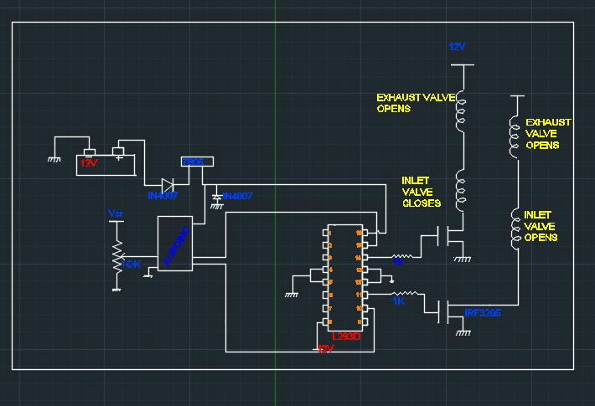
LINE DIAGRAM FOR VALVE ACTUATION OF CAMLESS ENGINE

The MOSFETs used are (IRF3205) which act as current amplifiers and amplify the current from 1 amp to 3 amps. Two solenoids are placed on the inlet and exhaust valves the piston of the solenoid is directly connected to the valve using a rubber tubing for motion transfer. Each solenoid consists of two set of copper windings with 12 mm dia,20 turns and 8 layered both the solenoid are oppositely connected and when actuated two sets of opposite windings get magnetized ,the piston inside solenoid moves up closing the valve the alternate valve is opened. The solenoids are rigidly placed over the cylinder head with the help of wood powder and glue which turns into concrete strong upon drying up. A solenoid is simply a specially designed electromagnet. A solenoid usually consists of a coil and a movable iron core called the armature. Here's how it works. When current flows through a wire, a magnetic field is set up around the wire. If we make a coil of many turns of wire, this magnetic field becomes many times stronger, flowing around the coil and through its center in a doughnut shape. When the coil of the solenoid is energized with current, the core moves to increase the flux linkage by closing the air gap between the cores. The movable core is usually spring-loaded to allow the core to retract when the current is switched off. The force generated is approximately proportional to the square of the current and inversely proportional to the square of the length of the air gap.

SOURCE CODE FOR THE MICROPROCESSOR:
intex_valve = 7;
intin_valve = 6;
intspd_ctrl = A0;
int del,del1;
void setup()
{
pinMode(ex_valve,OUTPUT);
pinMode(in_valve,OUTPUT);
pinMode(spd_ctrl,INPUT);
digitalWrite(ex_valve,HIGH);
digitalWrite(in_valve,HIGH);
}
void loop()
{
del=analogRead(spd_ctrl);
del1=map(del, 512, 0, 512);
if(del1<=20){del1=20;}
if(del1<=500){fire();}else
{
digitalWrite(ex_valve,HIGH);
digitalWrite(in_valve,HIGH);
}
}
void fire()
{
digitalWrite(ex_valve,HIGH);
digitalWrite(in_valve,HIGH);
delay(del1);
digitalWrite(ex_valve,LOW);
digitalWrite(in_valve,LOW);
}

OBESERVATIONS FROM THE TESTS CONDUCTED SOLENOID FORCE
The actual force required in the application is need to move the engine valve along with spring that must be considered.

The force can be calculated by:
F = (N*I)² μ₀ A / (2 g²),
Where:
- μ0 = 4π�10-7
- F is the force in Newtons
- N is the number of turns
- I is the current in Amps
- A is the area in length units squared
- g is the length of the gap between the solenoid and a piece of metal.
For different N values we get different solenoid force for valve operating
I=5amp, g=0.5, A=πdl. (d =2mm,l=5cm,)

SL.NO | NUMBER OF TURNS | SOLENOID FORCE | VALVE FREQUENCY PER SECOND
1 | 100 | 0.512 N | 14
2 | 120 | 0.738 N | 18
3 | 140 | 1.001 N | 22
4 | 160 | 1.310 N | 25
5 | 180 | 1.661 N | 28
6 | 200 | 2.050 N | 33

Valve Frequency
At average speed i.e the valve opening or closing time is 40ms
For 1 sec 25 openings and closings is possible
For 1 min for one valve 25*60=1500
With a force of 1.31N the inlet valve opens for 1500 times and exhaust valve opens fo 1500 times.

SL.NO | TIME TAKEN FOR ONE OPENING OR CLOSING IN MILLI SECONDS | NO OF OPENINGS OR CLOSINGS IN ONE SECOND | NO OF OPENINGS OR CLOSINGS IN MINUTE
1 | 71.4 | 14 | 840
2 | 55.5 | 18 | 1080
3 | 45.45 | 22 | 1320
4 | 40 | 25 | 1500
5 | 35.7 | 28 | 1680
6 | 30.30 | 33 | 1980

CONCLUSION
Looking back on this project, the overall outcome of results to be observed. This can be evaluated by looking at how well our objectives were met. Our first objective is to control the engine valve of an engine, select a linear actuator that meets specifications, and construct an electronic control system, deal with the design aspect of our project and were all almost achieved. More specifically, next objective, the electronic control system we constructed is able to read engine speeds from 0 to 3600 rpm and vary the valve timing depending on engine speed and operator inputs. However, our final objective, to obtain gains in horsepower, torque, and efficiency of 2% was not met because of not setting up in an engine but theoretically it should be done. We are confident though that this objective of installing in an engine can be met if more time for testing and facilities is given. There is a lot we could say about the need for variable valve timing. This design is very realistic for the future of the automotive industry as well as our education.

SOME OF THE ADVANAGES FROM THE ABOVE RESULTS
a)Eliminated Mechanical Linkages
b)It can make Engine clean , efficient and responsive
c)ECU can control the valve velocity acceleration and deceleration of valve
d)Reduction in size and weight
e)Fuel economy Increases
f)Power and Torque increase

REFERENCES

Anderson, M; Tsao, T-C; and Levin, M., 1998, “Adaptive Lift Control for a Camless Electrohydraulic Valvetrain,” SAE Paper No. 98102
- Ashhab, M-S; and Stefanopoulou, A., 2000, “Control of a Camless Intake Process – Part II,” ASME Journal of Dynamic Systems, Measurement, and Control – March 2000
- Gould, L; Richeson, W; and Erickson, F., 1991, “Performance Evaluation of a Camless Engine Using Valve Actuation with Programmable Timing,” SAE Paper No. 910450.
- Schechter, M.; and Levin, M., 1998, “Camless Engine,” SAE Paper No. 960581
- INTERNATIONAL JOURNAL OF ROBUST AND NONLINEAR CONTROL, Int. J. Robust Nonlinear Control 2001; 11:1023}1042 (DOI: 10.1002/rnc.643) (10)

